**KAMPALA PARENTS’ SCHOOL 2004**

**END OF YEAR ASSESSMENT, 2018**

**READING – TOP CLASS**

**Name: ______________________________ Group: ________**

**Date: ________________________________________________**

1. **Listen and write.**

________________ ________________

___________________________________________

1. **Write a word for the sound.**

ee s h e e p

ck _______________

oo _______________

ai _______________

u _______________

1. **Join and make words.**

|  |  |  |
| --- | --- | --- |
| ch  p  tr  sh | ai | r  nt  n  l |

1. **Write these correctly.**

cota _____________

depe _____________

glo _____________

sweets likes Ben. ______________________

banana A boy has a. ___________________________

1. 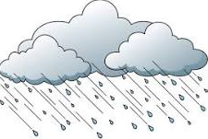**Name these pictures.**

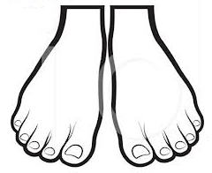_______________

_______________

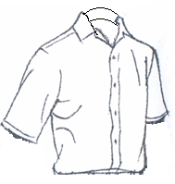_______________

_______________

1. **Make good sentences.**

like ____________________________________

meat ____________________________________

1. 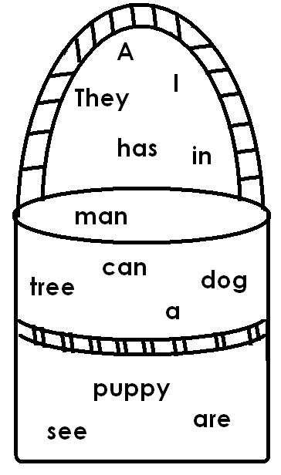**Make sentences using words in the basket.**

I can see a puppy.

_______________________________

_______________________________

_______________________________

1. 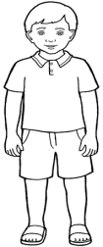**Fill in the correct words.**

Henry is a good _______________. He sweeps the house with a _______________. He washes his

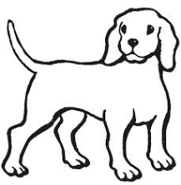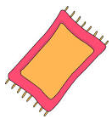 ______________ after taking tea. He cleans the table with a _____________. Then he plays with his _______________.

1. **Read correctly.**

